**Lesson 0**

Revision: Derivatives P.P.I.C.Q

*From MAT1613*

Derivatives are the slope of a function. It calculates the instantaneous rate of change at each point of the old function.

Common derivatives:

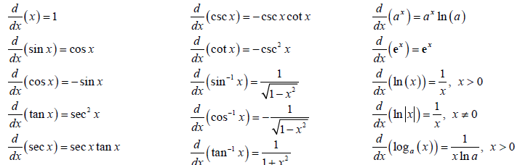

What is and what is the difference between and ?

is a function that takes one input.

Differentiation incomplete

*differentiation-with-respect-to-x*

or for brevity , is a function with its input y.

Differentiation complete

*the result of taking the derivative-with-respect-to-x of y*

**Lesson 0**

Differential Equation

<https://tutorial.math.lamar.edu/Classes/DE/Definitions.aspx>

A differential equation is any equation which contains derivatives, either ordinary derivatives or partial derivatives.

Example: Newton’s second law of motion

– force

– mass

– acceleration

Rewrite

or

Newton’s Second Law can now be written as a differential equation in terms of either the velocity, , or the position, , of the object as follows:

**Order**

The order of a differential equation is the largest derivative present in the differential equation.

**Ordinary Differential Equations** **(ODE)**

has ordinary derivatives in it

**Partial Differential Equations** **(PDE)**

has partial derivatives in it

Example:

Show that is a solution to for

*first derivative*

*second derivative*

*Substitute into ODE*

*Hence, satisfies the differential equation and is a solution*

**Initial conditions**

Initial Condition(s) are a condition, or set of conditions, on the solution that will allow us to determine which solution that we are after. Initial conditions are values of the solution and/or its derivative(s) at specific points. For the above example, there are actually an infinite number of solutions:

Therefore, the same example with initial conditions:

Example:

Show that is a solution to

, ,

is the only solution to this differential equation.

**Initial Value Problem**

An Initial Value Problem (or IVP) is a differential equation along with an appropriate number of initial conditions.

The following are examples of IVP’s:   
 , ,

,

**Interval of Validity**

The interval of validity for an IVP with initial condition(s)

//TODO

**General Solution**

The general solution to a differential equation is the most general form that the solution can take and doesn’t take any initial conditions into account.

Example: the general solution to is

**Implicit/Explicit Solution**

**Lesson 0**

Direction/Slope Fields

It’s impossible to find explicit formulas for solutions of some differential equations. Even if there are such formulas, they may be so complicated that they’re useless. In this case we may resort to graphical or numerical methods to get some idea of how the solutions of the given equation behave.

Slope

<https://www.youtube.com/watch?v=Wr9VOum9Co0>

|  |  |
| --- | --- |
| Gradient | Drawing |
|  |  |
| undefined |  |
|  |  |
|  |  |
|  |  |
|  |  |
|  |  |

Example: draw the slope field of

*Remember that y-prime is dependent on*

Step 1: draw a table to show function values/gradients

|  |  |  |  |
| --- | --- | --- | --- |
|  |  |  | Explanation |
| -2 |  | -2 | *anywhere , the gradient is* |
| -1 |  | -1 | *anywhere , the gradient is* |
| 0 |  | 0 | *anywhere , the gradient is* |
| 1 |  | 1 | *anywhere , the gradient is* |
| 2 |  | 2 | *anywhere , the gradient is* |

Step 2: solve the differential equation

This will guide us on the shape of one of the solution curves

*is also*

*multiply both sides by*

*find the anti-derivative of both sides*

Step 3: draw the slope field

Then, draw one of the solution curves

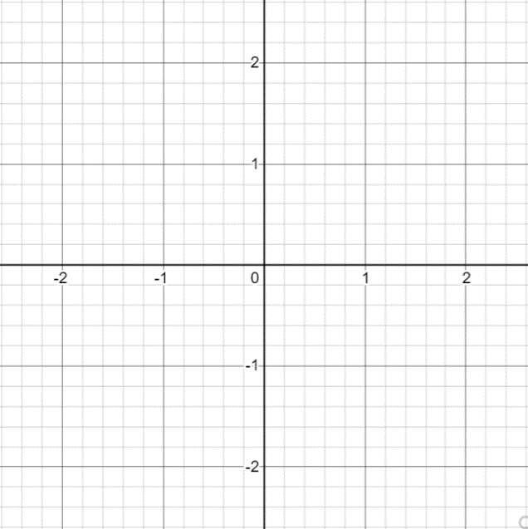

Example: draw the slope field of

*Remember that y-prime is dependent on*

Step 1: draw a table to show function values/gradients

|  |  |  |  |
| --- | --- | --- | --- |
|  |  |  | Explanation |
|  | -2 | -2 | *anywhere y, the gradient is* |
|  | -1 | -1 | *anywhere y, the gradient is* |
|  | 0 | 0 | *anywhere y, the gradient is* |
|  | 1 | 1 | *anywhere y, the gradient is* |
|  | 2 | 2 | *anywhere y, the gradient is* |

Step 2: solve the differential equation

This will guide us on the shape of one of the solution curves

*is also*

*multiply both sides by*

*divide both sides by*

*divide both sides by*

*find sthe anti-derivative of both sides*

*is also just a constant c*

Step 3: draw the slope field

Then, draw one of the solution curves



Example: draw the slope field of

Step 1: draw a table to show function values/gradients

|  |  |  |  |
| --- | --- | --- | --- |
|  |  |  | Explanation |
| 0 | 0 | 0 | *anywhere y, the gradient is* |
| 1 | 1 | 0 | *anywhere y, the gradient is* |
| 2 | 2 | 0 | *anywhere y, the gradient is* |
|  |  |  |  |
| 1 | 0 | 1 | *Pattern for solution curve* |
| 2 | 1 | 1 | *Pattern for solution curve* |
| 0 | -1 | 1 | *Pattern for solution curve* |
|  |  |  |  |
| 2 | 0 | 2 | *Pattern under solution curve* |
| 3 | 1 | 2 | *Pattern under solution curve* |
|  |  |  |  |
| 0 | 1 | -1 | *Pattern above solution curve* |
| 1 | 2 | -1 | *Pattern above solution curve* |
|  |  |  |  |
| 0 | 2 | -2 |  |
| 3 | 0 | 3 |  |

*Wherever , y-prime is 0*

Step 2: solve the differential equation

This will guide us on the shape of one of the solution curves

*is also*

**ODE: first order linear**

**//TODO**

Step 3: draw the slope field

Then, draw one of the solution curves



**Lesson 0**

Ordinary Differential Equations (ODE) - S.H.I.E

<https://www.youtube.com/watch?v=IFpT-Ptmkyg&ab_channel=MathbyLEO>

has ordinary derivatives in it

Different methods to solve ODE’s:

[1] 1 separate x terms and y terms

[2] integrate both sides

Implicit: (y-terms).dy=(x-terms).dx + c

Explicit: y = mx+c

[1] Seperable Equations

*Write in standard form*

[2] Homogenous method

[1] check if homogenous

f(kx,ky) = f(x,y)

*Identify the functions and*

[1] find P(x)

[2] find M(x) (aka integrating factor I(x))

[3] multiply equation by M(x)

[3] Integrating factor

*Identify the Integrating factor*

or

[4] Exact Differential Equations

[1] identify if it is standard form

M(x,y).dx + N(x,y).dy = 0

*Or*

Remember:

[2] identify M an N

[3] Check if it is exact DE

[4] Integrate M or N

*Write the general solution*

**ODE: first order linear**

example: Solve for

*write in standard form*

**ODE: first order linear**

example: Solve for

*write in standard form*

**Lesson 0**

Partial Differential Equations (PDE)

A PDE is called linear if it is linear in the unknown and its derivatives.

If is zero everywhere then the linear PDE is homogeneous, otherwise it is inhomogeneous.

**Divergence of a function:**

dot product of the del operator and the function

**Laplacian:**

dot product of del and divergence

The maximum rate of change at a given point:

This is useful in cases where you want to transform a 3D interpretation of a graph to a 2D one (i.e. Quadric surface of a mountain to a contour plot)

This also helps us find the direction that the gradient vector increases towards the fastest

. ­

*the gradient vector increases the fastest towards y*

This is how we solve linear equations in (from MAT2615) of the form :

*Systems of equations for three variables*

In a vector field , suppose is a curve in parametrized by

Independent variables

**Cauchy problem of the form**

We also had

The gradient of a function is the 2D vector function:

*divergence of a function.*

Example:

The third coordinate in functions indicate that represents a surface

**Quasilinear PDE (FOQPDE):**

These are equations that are nonlinear. They have the property that there are no products of derivatives. Equations like this can often be solve by the method of characteristics.

<https://web.stanford.edu/class/math220a/handouts/firstorder.pdf>

FOQPDE’s of two variables are of the form :

*where and are continuous functions*

*with respect to the three variables*

Independent variables

Dependent variables (unknown functions)

**Cauchy problem of the form**

or

*Direction of the normal to S (lie on a plane tangent to S)*

This is almost the same as before, but now the third coordinate in functions that would indicate that represents a surface is .

**Characteristics**

We go a step further, so instead of looking at a plane tangent to S, we consider a path on S.

**Characteristic equations**

[1]

[2]

[3]

The family of curves in the surface S  
 denoted by

*Integral curve*

Remember that:

Initial curve: parametrize by

Integral curve: union of each point of the curve

we need to prescribe three pieces of initial data.

Initial curve: parametrize by

**Initial conditions (boundary condition)**

**Method of characteristics**

This will be how we solve nonlinear equations

*Systems of fully nonlinear equations*

FOQPDE’s of two variables

**Cauchy problem of the form**

Independent variables

Dependent variables (unknown functions)

We need to prescribe initial values for and .

These are introduced to replace and .

They are our initial data/conditions. Let’s neaten up our equation:

We can find our integral curve as a solution to the following system of characteristic ODE’s

**Characteristic equations**

[1]

[2]

[3]

[4]

[5]

we need to prescribe five pieces of initial data.

Initial curve: parametrize by

**Initial conditions (boundary condition)**

**Lesson 0**

Second Order Linear Nonhomogeneous Differential Equations with Constant Coefficients

https://www.math24.net/second-order-linear-nonhomogeneous-differential-equations-constant-coefficients

The nonhomogeneous differential equation of this type has the form

where p, q are constant numbers (that can be both as real as complex numbers).

For each equation we can write the related homogeneous or complementary equation:

Two methods exist to solve these:

**Method of variation of constants**

**Method of undetermined coefficients**